Digital Forensics Investigation Using Autopsy: Case Creation and Evidence Import
EXPERIMENT NO: 05
DATE:
1. AIM
To use the Autopsy digital forensics platform to create a new forensic case, import digital evidence (disk image files), configure ingest modules, and perform basic forensic analysis and reporting.

2. SOFTWARE / TOOLS REQUIRED
- Operating System: Windows, Linux, or macOS
- Forensics Tool: Autopsy Digital Forensics Platform
- Evidence Files: Disk image files (4Dell Latitude CPi.E01, 4Dell Latitude CPi.E02) downloaded from the provided forensic repository.

3. DESCRIPTION
Autopsy is a premier open-source digital forensics platform and graphical interface to The Sleuth Kit and other digital forensics tools. It is widely used by law enforcement, military, and corporate examiners to analyze and extract critical data from digital devices.
In a standard forensic investigation, raw data or disk images (such as .E01, .dd, or .raw formats) are imported into a securely managed "Case". Autopsy utilizes various Ingest Modules (like File Type Identification, Keyword Searching, Timeline Analysis, and Hash Lookups) to process this evidence in the background, automatically categorizing artifacts such as web history, file system metadata, and communication records for the examiner to review. Autopsy is the premier end-to-end open source digital forensics platform. Built by Sleuth Kit Labs with the core features you expect in commercial forensic tools, Autopsy is a fast, thorough, and efficient hard drive investigation solution that evolves with your needs.

4. PROCEDURE
Step 1: Installation & Preparation
- Download and install the Autopsy application based on the host operating system.
- Download the required evidence files (4Dell Latitude CPi.E01) to a secure local directory.
- Launch the Autopsy application to view the welcome screen.

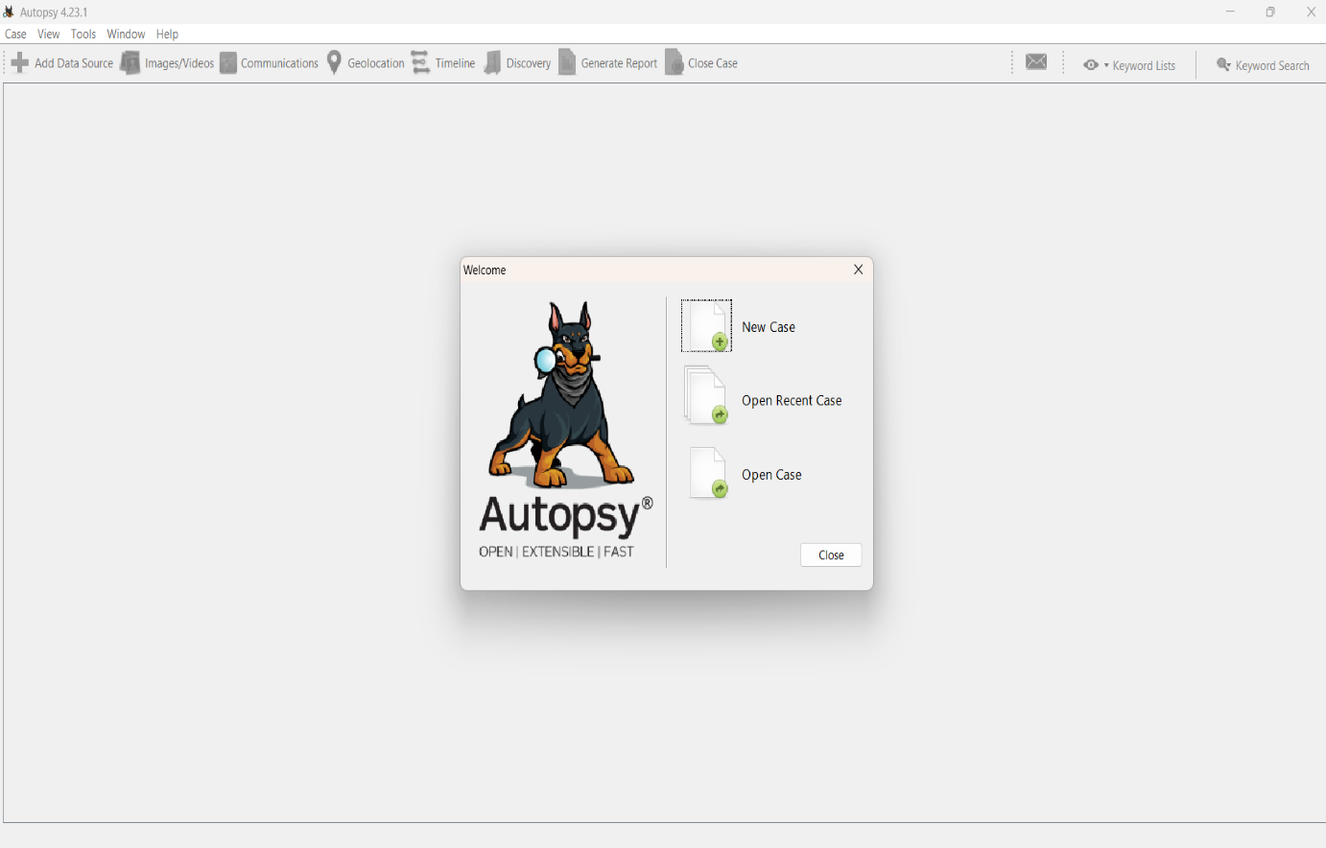Figure 1: Autopsy startup menu and tool interface

Step 2: Starting a New Case
- Click on New Case from the startup menu.
- Enter the case name (e.g., EX05) and specify the base directory where the case data will be stored.
- Click Next to proceed to the optional information.
- Fill in the required case details, including the case number and examiner's name (Aasif Ahmed A), then click Finish.
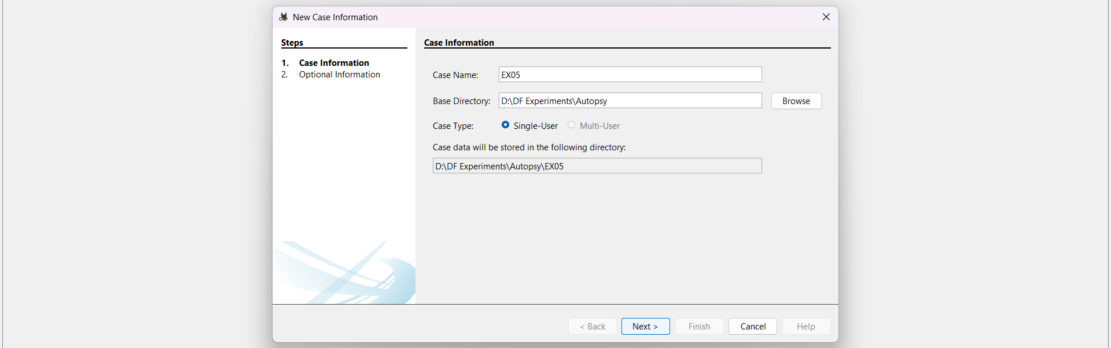Figure 2: Creating a new forensic case and setting the base directory
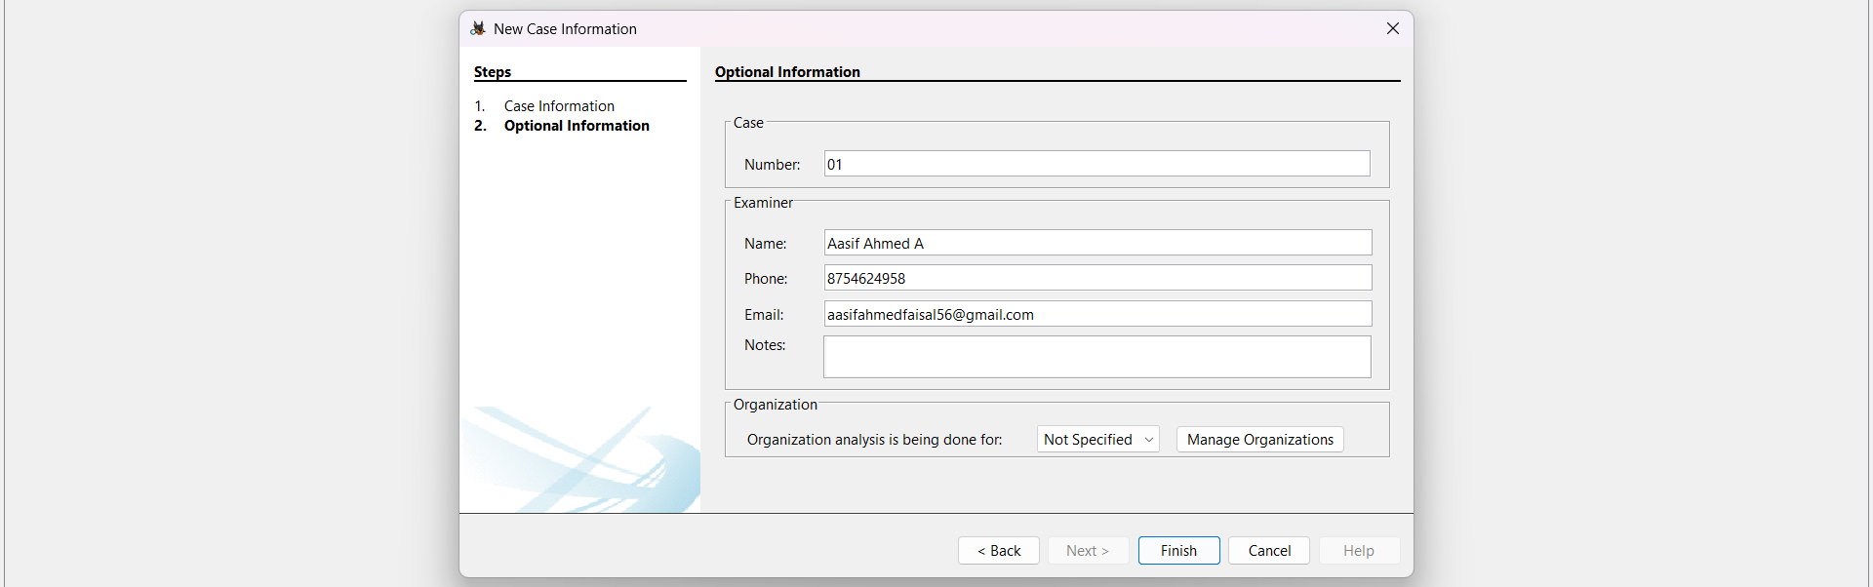
Figure 3: Entering Optional Information including Examiner details

Step 3: Adding a Data Source
- When prompted to add a data source, choose the type of data source (e.g., Disk Image or VM file).
- Browse to the local directory and select the downloaded evidence file (4Dell Latitude CPi.E01).
- Configure Ingest Modules: Select the specific analysis modules required for the investigaion.
- Click Next to start the analysis.
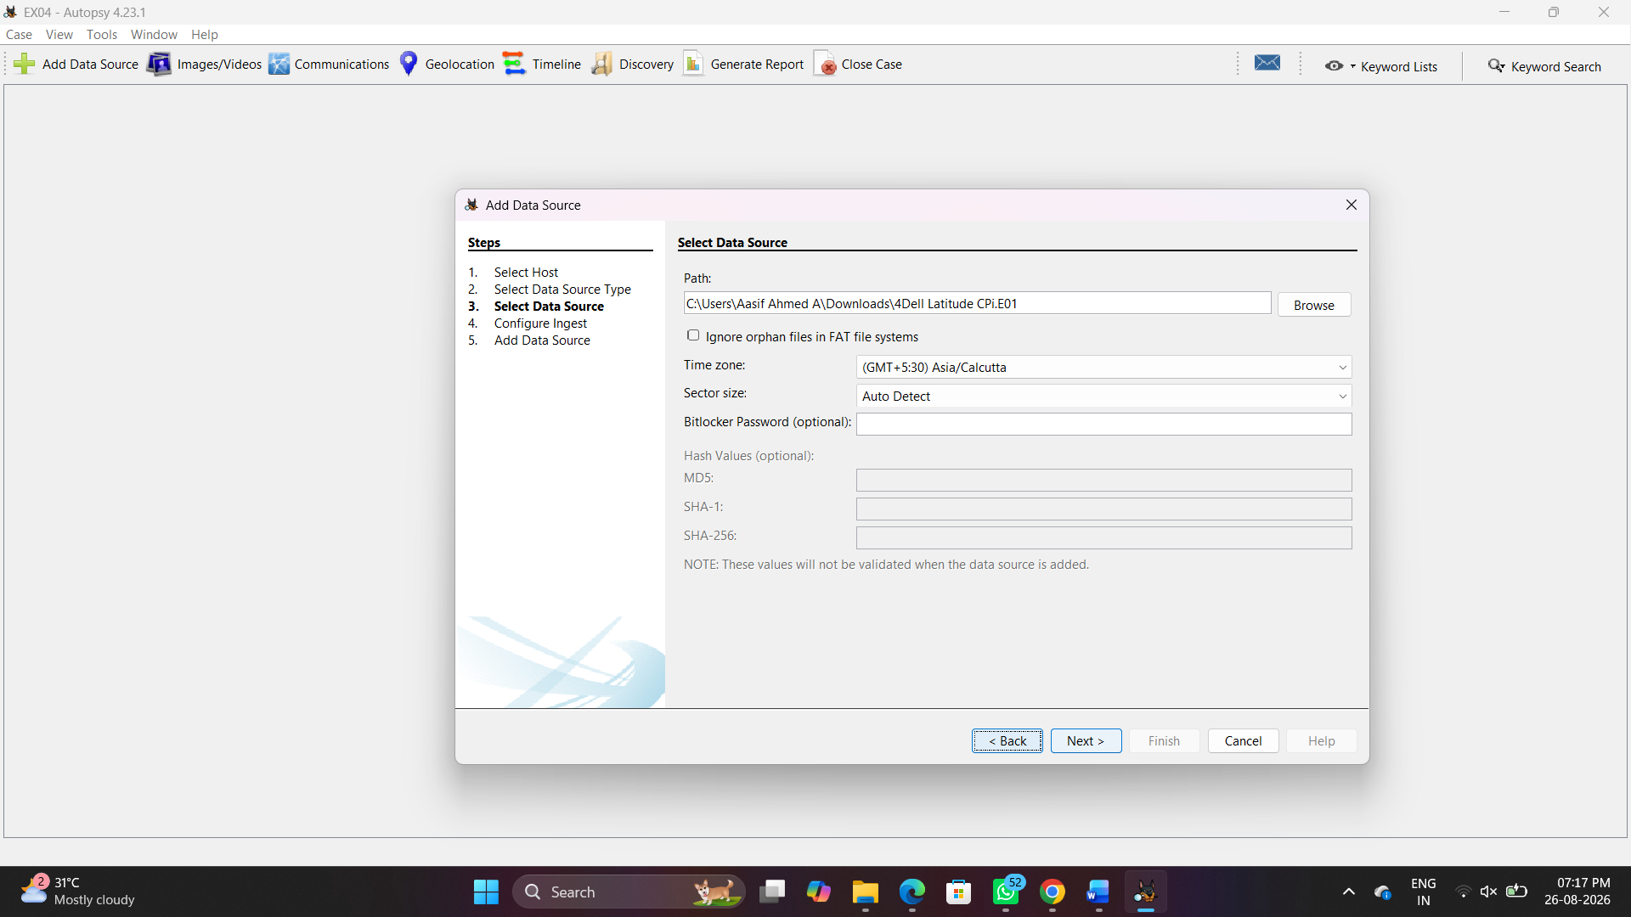Figure 4: Importing the .E01 evidence file data source
Step 4: Initial Analysis and Overview
- Monitor the Ingest Progress in the lower-left corner of the interface as Autopsy processes the data source.
- Once processing yields results, use the Tree Viewer on the left pane to explore different categorized aspects like File System, Deleted Files, Data Artifacts, etc.
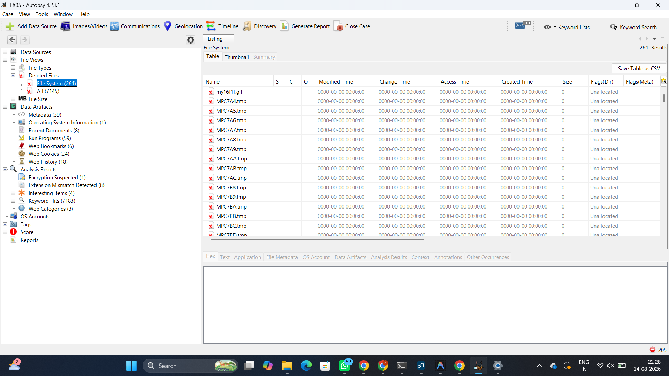Figure 5: Exploring categorized forensic artifacts and deleted files in the Tree Viewer
Step 5: Detailed Analysis
- File Analysis: Navigate through files and folders under the File Types or File System section. Open, view, or extract files for further examination.
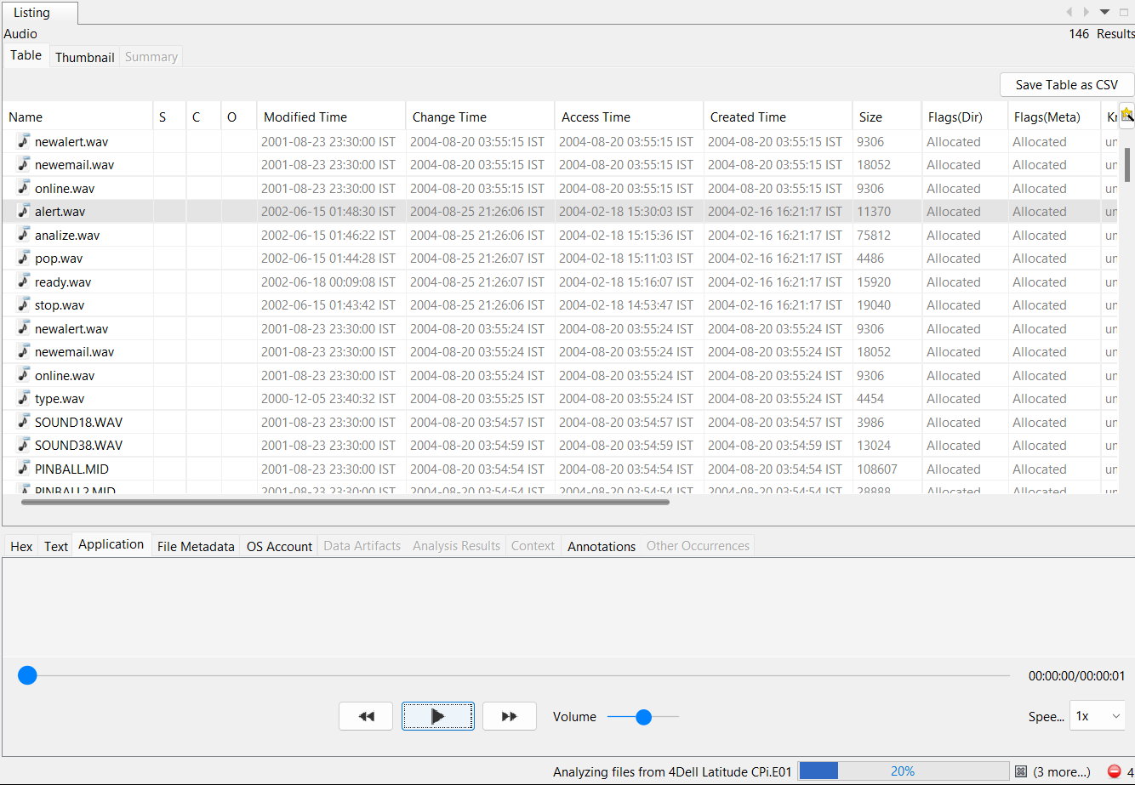
- Select an individual file (e.g., audio files under the Audio category) to view its hex, text, application, or file metadata in the lower pane.
Figure 6: Detailed analysis and viewing extracted files (e.g., Audio playback and metadata)
Step 6: Reporting and Case Closure
- Click on Generate Report from the main toolbar.
- Choose the desired report format (e.g., Excel Report, HTML Report) under the Select and Configure Report Modules window.
- Click Next and select the specific result types to include (e.g., Accounts, E-Mail Messages, etc.).
- Review the generated report to ensure all relevant information and exported artifacts are accurately documented.
- Once the investigation is complete, close the case within Autopsy and archive all data according to organizational policies.

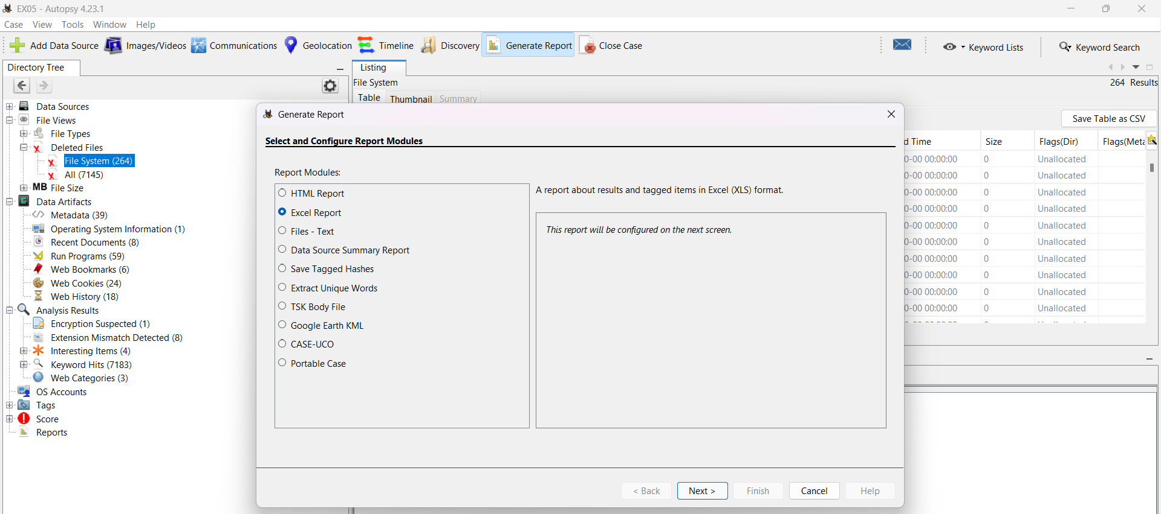
Figure 7: Selecting the report module format
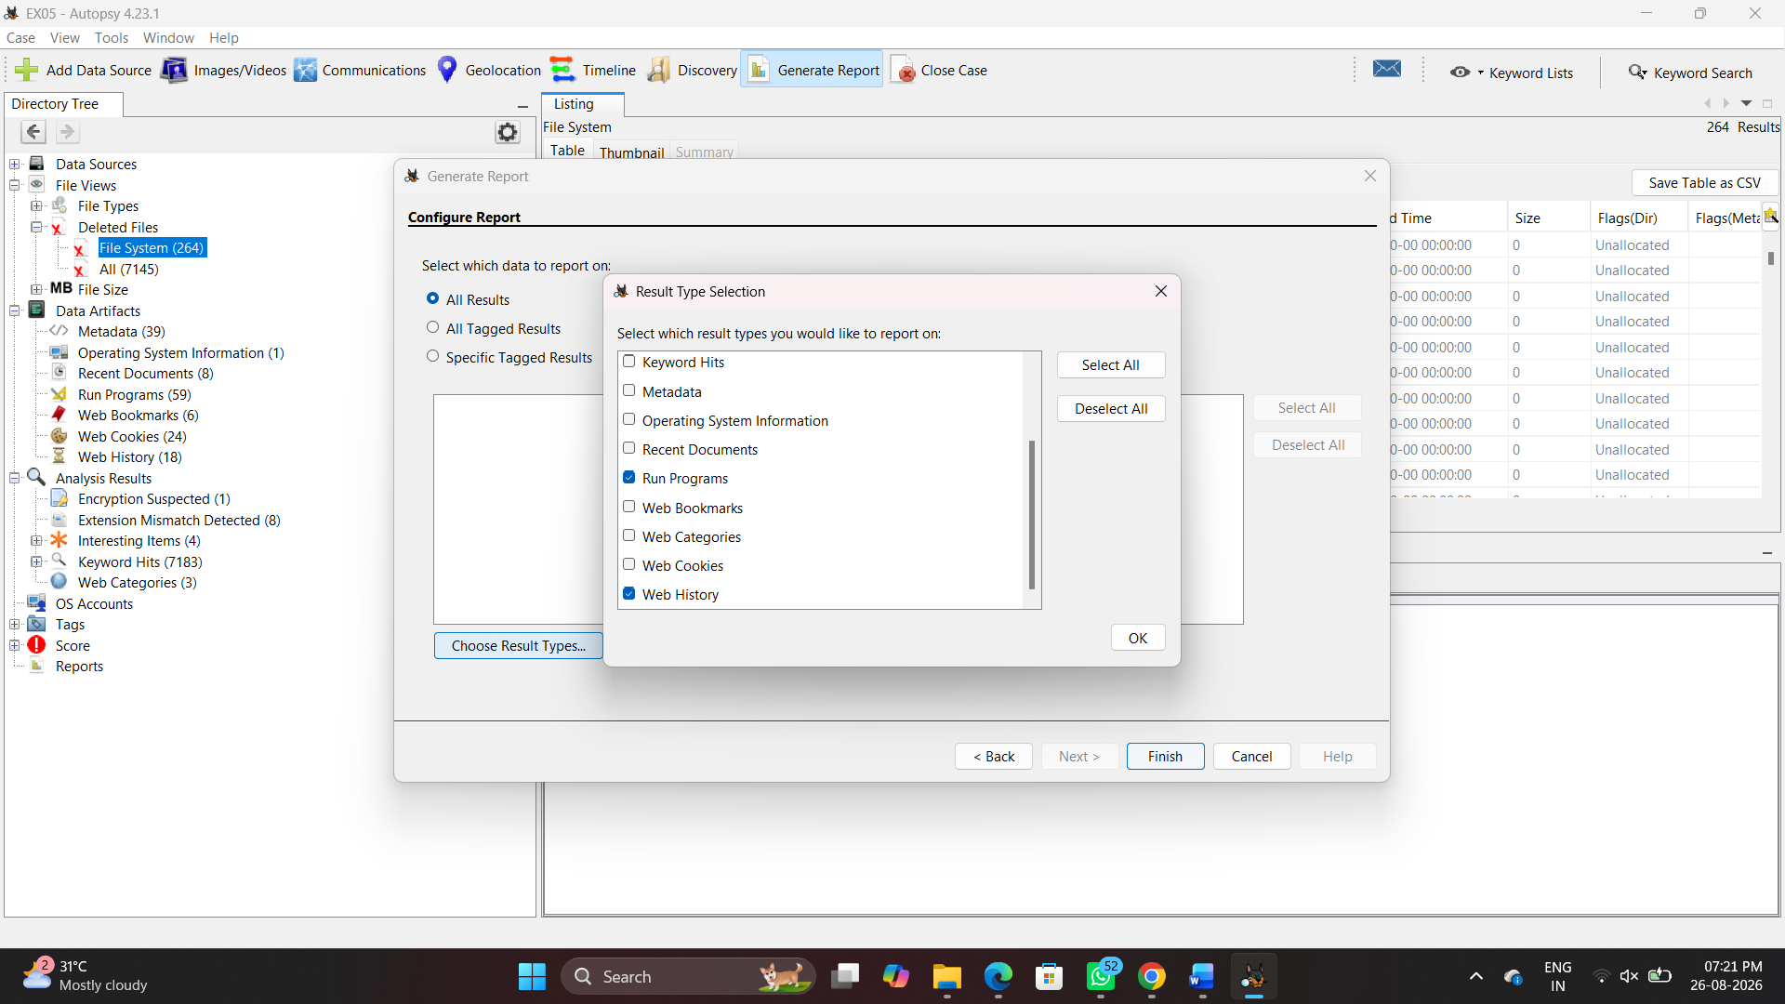Figure 8: Configuring the report by selecting specific tagged data

5. RESULT
The digital forensics experiment was successfully completed. A new case was established in Autopsy, and the provided .E01 disk image evidence was successfully imported, analyzed using ingest modules, and documented via the reporting feature.

